SYDNEY WESTERN CITY PLANNING PANEL

Panel No: | 2019WCI033.
DA Number: | 2019/324/1.
Local Government Area: | Camden.
Development: | Demolition of the dwelling house at 40 Somerset Avenue and construction of five residential flat buildings accommodating 100 apartments, with a mix of terrace style dwellings and apartments; flexible communal rooms for residents; single level basement car park for each building incorporating a total of 141 vehicle spaces; lockable bike storage area for 34 bicycles; landscaping works including external areas and landscaped roof-top terraces for residents; basement waste bin rooms; and a new internal access road.
Street Address(es): | • 38 Somerset Ave, Narellan – Lot 21 / DP 30539  • 40 Somerset Ave, Narellan – Lot 22 / DP 30539  • 42 Somerset Ave, Narellan – Lot 23 / DP 201585  • 44 Somerset Ave, Narellan – Lot 24 / DP 201585  • 46 Somerset Ave, Narellan – Lot 25 / DP 201585  • 48 Somerset Ave, Narellan – Lot 26 / DP 201585  • 50 Somerset Ave, Narellan – Lot 27 / DP 201585  • 52 Somerset Ave, Narellan – Lot 28 / DP 201585  • 54 Somerset Ave, Narellan – Lot 29 / DP 201585  • 56 Somerset Ave, Narellan – Lot 30 / DP 201585  • 58 Somerset Ave, Narellan – Lot 31 / DP 201585  • Part of 3 Elyard Street, Narellan – Lot 6 / DP 812672
Applicant / Owner: | Elyard Gardens Development Pty Ltd / Elyard Property Holdings
Date of DA Lodgement: | 26 April 2019
Number of Submissions: | Four (two submissions and two petitions with a total of 106 signatures)
Recommendation: | Approve with conditions
Regional Development Criteria (Schedule 7 of State Environmental Planning Policy (State and Regional Development) 2011): | General development capital investment value >$30 million
List of All Relevant s4.15(1)(a) Matters: | - State Environmental Planning Policy (State and Regional Development) 2011;  - Camden Local Environmental Planning Policy 2010;  - State Environmental Planning Policy No. 65 – Design Quality of Residential Apartment Development;  - State Environmental Planning Policy No 55 - Remediation of Land;  - Sydney Regional Environmental Plan No 20 - Hawkesbury-Nepean River; and  - Camden Development Control Plan 2011.
List all Documents Submitted with this Report for the Panel’s Consideration: | - Assessment report.  - Camden Local Environmental Plan 2010 assessment table.  - Camden Development Control Plan 2011 assessment table.  - Apartment Design Guide assessment table.  - Recommended conditions.  - Proposed plans.  - Traffic Report.  - Submissions.  - Correspondence from the NSW Rural Fire Service, NSW Roads and Maritime Service and the Camden Local Area Command of the NSW Police.
Report Prepared By: | Clare Aslanis, Executive Planner
Report Date: | November 2019

Summary of Section 4.15 matters

Have all recommendations in relation to relevant s4.15 matters been summarised in the Executive Summary of the assessment report? | Yes.

Legislative Clauses Requiring Consent Authority Satisfaction

Have relevant clauses in all applicable environmental planning instruments where the consent authority must be satisfied about a particular matter been listed and relevant recommendations summarised in the Executive Summary of the assessment report? | Yes

Clause 4.6 Exceptions to Development Standards

If a written request for a contravention to a development standard (clause 4.6 of the Growth SEPP) has been received, has it been attached to the assessment report? | N/A

Special Infrastructure Contributions

Does the DA require Special Infrastructure Contributions (s7.24)? | No

Conditions

Have draft conditions been provided to the applicant for comment? | Yes

PURPOSE OF REPORT

The purpose of this report is to seek the Sydney Western City Planning Panel’s (the Panel’s) determination of a development application (DA) for a residential flat building development comprising 100 dwellings at 38-58 Somerset Avenue, Narellan.

The Panel is the consent authority for this DA as the capital investment value (CIV) of the development is $33,608,000. This exceeds the CIV threshold of $30 million for Council to determine the DA pursuant to Schedule 7 of State Environmental Planning Policy (State and Regional Development) 2011.

SUMMARY OF RECOMMENDATION

That the Panel determine DA/2019/324/1 for the construction of a residential flat building development comprising 100 dwellings pursuant to Section 4.16 of the Environmental Planning and Assessment Act 1979 by granting consent subject to the conditions attached to this report.

EXECUTIVE SUMMARY

Council is in receipt of a DA for the construction of a residential flat building development comprising 100 dwellings at 38-58 Somerset Avenue, Narellan.

The DA has been assessed against the Environmental Planning and Assessment Act 1979, the Environmental Planning and Assessment Regulation 2000, relevant environmental planning instruments, development control plans and policies.

A summary of the assessment of all relevant environmental planning instruments is provided below with a detailed assessment provided later in the report.

State Environmental Planning Policy (State and Regional Development) 2011. | The Panel is the consent authority for this DA as the development has a CIV of $33,608,000 which exceeds the CIV threshold of $30 million for Council to determine the DA.
State Environmental Planning Policy No 55 - Remediation of Land. | Determination No. 2016/19/1, dated 28 November 2016, approved the remediation of the site known as 3 Elyard Street, Narellan. The remediation works have been completed and the Site Audit Statement required under this determination is currently being finalised and a condition requiring this to be submitted to Council’s satisfaction prior to the issue of any construction certificate is included in the recommended conditions.  The dwellings on the lots fronting Somerset Avenue, with the exception of 40 Somerset Avenue, have previously been approved for demolition (Determination No. 2017/1364/1, 19 December 2017). A preliminary site investigation for these sites was also submitted which found them suitable for residential development pending post demolition inspections of the land within the footprint of the dwellings. A standard contingency condition is recommended that requires any contamination found during construction to be managed in accordance with Council's Management of Contaminated Lands Policy.
State Environmental Planning Policy No. 65 – Design Quality of Residential Apartment Development | The proposal has been assessed against State Environmental Planning Policy No. 65 – Design Quality of Residential Apartment Development (SEPP 65) and the Apartment Design Guide (ADG). The proposal is generally compliant with the provisions of SEPP 65 and the ADG.
Sydney Regional Environmental Plan No 20 - Hawkesbury-Nepean River (SREP 20). | The development is consistent with the aim of SREP 20 (to protect the environment of the Hawkesbury-Nepean River system) and all of its planning controls.
Camden Local Environmental Plan 2010. | The development is permitted with consent in the applicable R3 Medium Density Residential zone; is consistent with the objectives of the zone; and is generally compliant with the other matters for consideration. Only the private road is proposed in the B2 zone, and roads are permissible with consent in that zone.

The DA was notified to surrounding properties for a 14 day period between 13 May and 1 June 2019. Two individual submissions and two petitions with a total of 106 signatures were received.

The development has been assessed against State Environmental Planning Policy No. 65 – Design Quality of Residential Apartment Development, Camden Local Environmental Plan 2010 and Camden Development Control Plan 2011. The development is consistent with these planning policies and controls in that it will provide residential accommodation in close proximity to the Narellan Town Centre.

The applicant has submitted a traffic report in support of the DA. The traffic report demonstrates that the development will not have a significant negative impact upon the surrounding road network and the operation of nearby intersections. The report acknowledges that wait times during peak periods are longer, however are not unacceptable when measured as an average per hour. Council staff have reviewed the report and support its findings.

The applicant has submitted an adequate stormwater management strategy that, subject to the attached conditions, will provide adequate stormwater management.

Based on the assessment, it is recommended that the DA be approved subject to the conditions attached to this report.

KEY PLANNING CONTROLS

Control | Proposed | Variation
Maximum density for residential flat buildings (1 unit per 200sqm of site area) – 72 dwellings | 100 dwellings | Additional 28 dwellings (39%)

AERIAL PHOTO

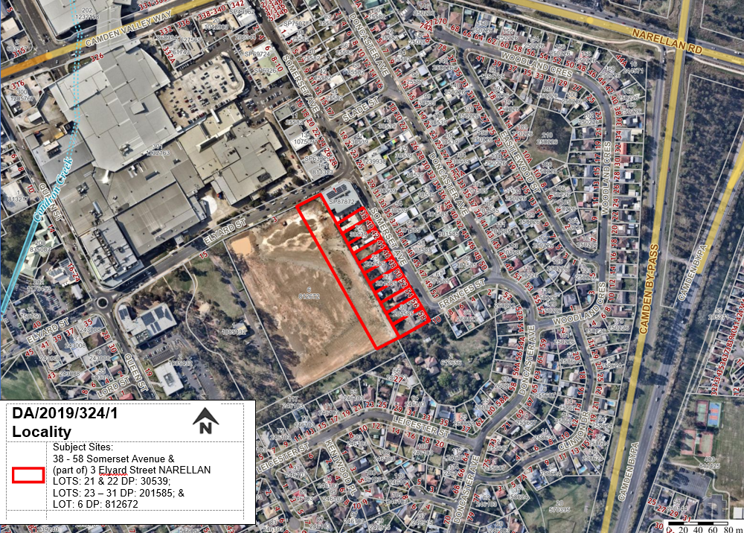
Figure 1: Site Location Map. The development site outlined in red. Narellan Town Centre shopping centre is visible in the north western part of the image.
THE SITE

The development site is situated on the western side of Somerset Avenue. The subject site sits across 12 allotments, 11 of which are currently occupied by older stock single dwellings which front Somerset Avenue, the 12th is larger vacant lot at the rear of these 11 dwellings with road frontage to Elyard Street (this larger site is known as Elyard Gardens).

The subject site has a total area of 1.44 ha.

The site has a gentle slope from Somerset Avenue to the rear of the existing residential dwelling properties, with an embankment extending into 3 Elyard Street.

The demolition of ten of the dwellings fronting Somerset Avenue (with the exception of 40 Somerset Avenue) was approved under DA/2017/1364/1. This consent requires a Hazardous Building Materials Assessment to be conducted prior to demolition and strict demolition controls given the likely presence of asbestos. The demolition of these dwellings has not yet commenced.

Remediation works on the Elyard Gardens lot were approved under DA/2016/19/1, the site was previously used for quarrying, landfill, then subsequently as a hardware store and steel yard following the completion of landfilling and capping. The remediation works have been completed and the Site Audit Statement required under this determination is currently being finalised.

ZONING PLAN

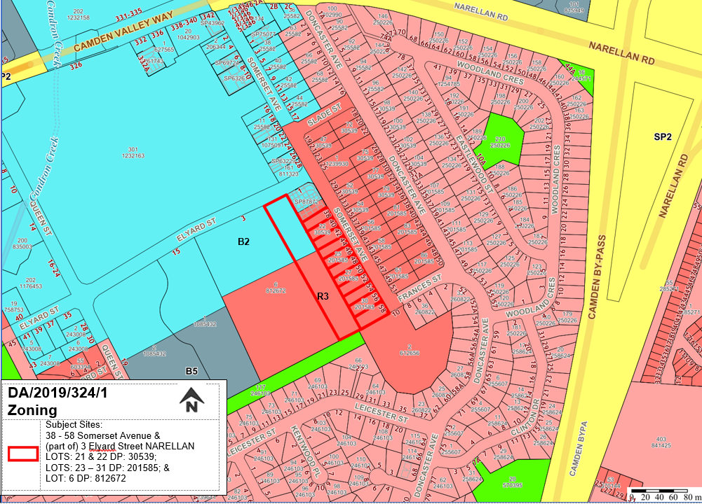
Figure 2: Site Zoning Plan. The proposed residential flat building is contained wholly within the R3 Medium Density Residential zone.
HEIGHT OF BUILDINGS PLAN

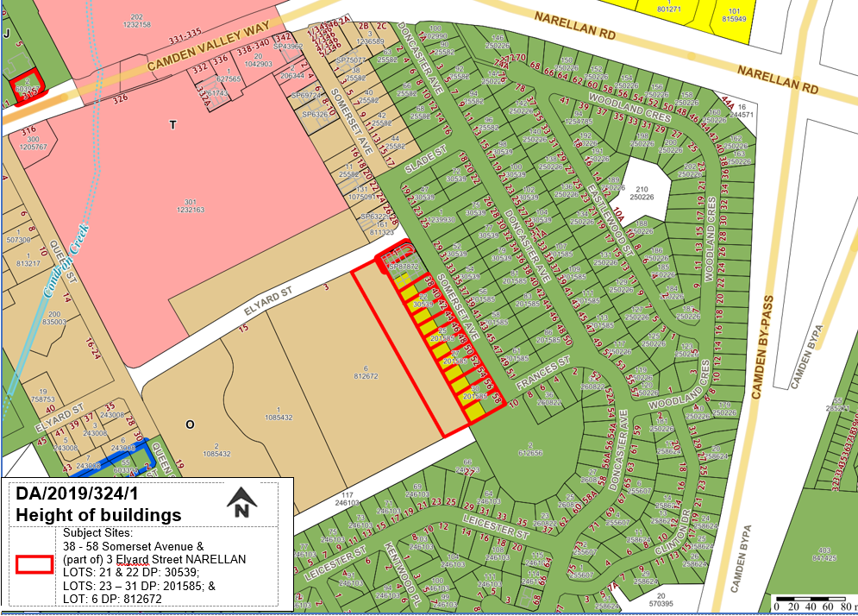
Figure 3: Height of Buildings Plan. The site is subject to split height limits of 9.5m (green), 12.5m (yellow) and 15.5m (brown). The proposal has responded to the height limits and is contained wholly within the prescribed heights.

HISTORY

The relevant development history of the site is summarised in the following table:

Date | Development
19 December 2019. | Approval of DA/2017/1364/1 for the demolition of ten dwelling houses fronting Somerset Avenue (excluding 40 Somerset Avenue), removal of trees and site clearing. Approval for the demolition of the dwelling house at 40 Somerset Avenue is sought as part of this development application (refer figure 4 below).
22 November 2018. | Approval of DA/2016/19/1 to carry out remediation works at 3 Elyard Street, Narellan.

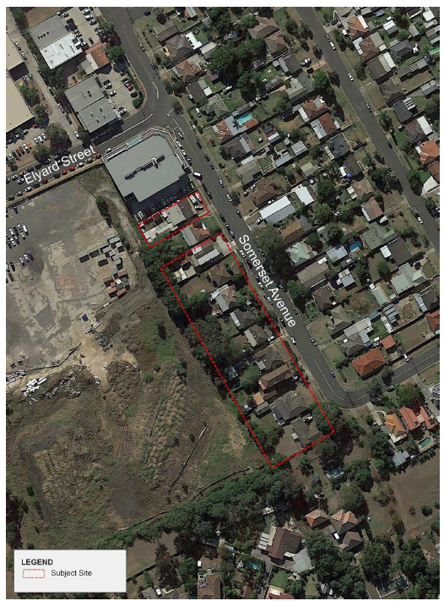

Figure 4: Lots approved for demolition as per DA/2017/1364/1 (the approved plan did not include 40 Somerset Avenue)

THE PROPOSAL

The development application seeks approval for the erection of a staged strata title development comprising five residential flat buildings ranging in height from two to four storeys incorporating the following components:

- Erection of five residential flat buildings accommodating 100 apartments, with a mix of terrace style dwellings and 1, 2 and 3 bedroom apartments;
- Common flexible communal rooms for residents;
- Single level basement car park for each building incorporating a total of 141 vehicle spaces;
- Lockable bike storage area for 34 bicycles within the basement car park areas;
- Basement storage areas for both residents and bulk storage areas;
- Landscaping works including external areas and landscaped roof-top terraces for residents; and
- Basement waste bin rooms.

The development is to be completed in three stages as indicated in Figure 5 below.

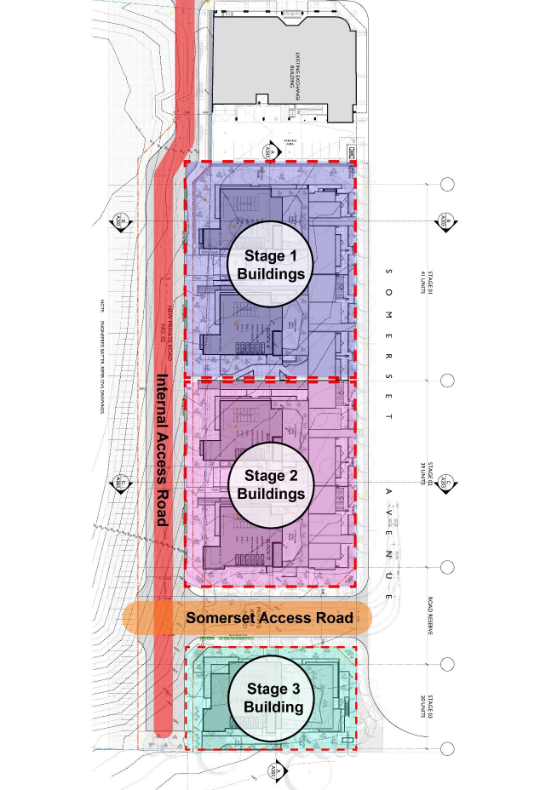
Figure 5: Staging Plan

Stages 1 and 2 – Buildings A, B, C and D

Stages 1 and 2 include a total of 80 units, comprising:

- 23 x 1 bed units
- 53 x 2 bedroom units
- 4 x 3 bedroom units.

This includes 14 x two-bedroom terrace dwellings fronting Somerset Avenue, with private open space courtyards fronting the roadway. The terrace dwellings are provided with direct / private gated access to Somerset Avenue. The units at the rear of the site (closer to the new private road) are in the form of a more traditional residential flat building up to 4 storeys in height.

A central lift well for each building provides access to each floor via a central corridor. Internal ground floor units are provided with open private garden terraces which address the internal communal open space areas and the internal private roadways.

Each building also incorporates a communal rooftop terrace area along the north-eastern elevation.

Lockable private resident storage areas are provided on the ground floor (beneath the Somerset Avenue fronting terraces style dwellings).

A single level basement carpark is proposed for buildings A and B which accommodates 49 resident parking spaces, 9 visitor parking spaces and 14 bicycle storage spaces, a waste compaction room, bin storage area for 43 bins, bulk waste storage room and infrastructure rooms.

A single level basement carpark is proposed for buildings C & D which accommodates 47 resident parking spaces, 8 visitor parking spaces and 13 bicycle storage spaces, a waste compaction room, bin storage area for 41 bins, bulk waste storage room and infrastructure rooms.

Stage 3 – Building E

Stage 3 includes Building E which is a 4 storey residential flat building with a total of 20 units comprising:

- 4 x 1 bed units
- 15 x 2 bedroom units
- 1 x 3 bedroom units.

Ground floor units are provided with open private garden terraces which address Somerset Avenue and the internal private roadways. Direct pedestrian access is provided to the building from the new internal private roadway.

Consistent with the other stages, the building also incorporates a communal rooftop terrace area along the north-eastern elevation.

A single level basement carpark is proposed which accommodates 24 resident parking spaces, 4 visitor parking spaces and 7 bicycle storage spaces. The basement also provides for a waste compaction room, bin storage area for 21 bins, bulk waste storage room and infrastructure rooms.

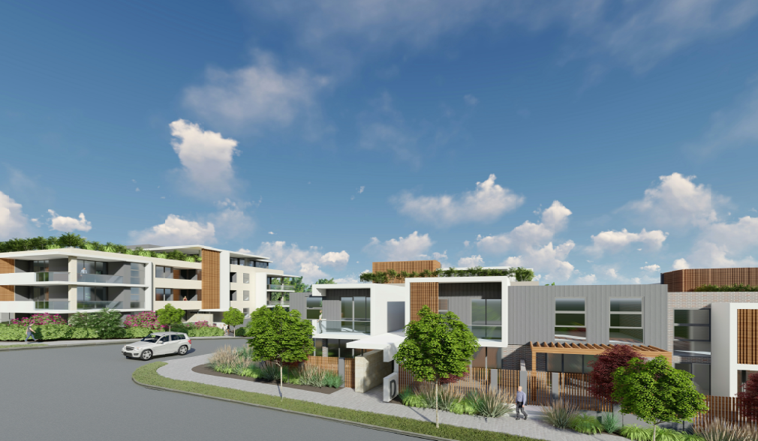
Figure 6: Artist Impression of Buildings D and E viewed from Somerset Avenue

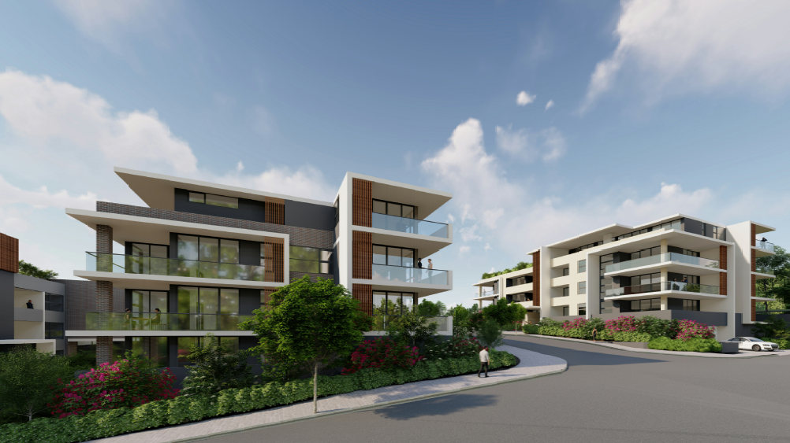
Figure 7: Artist Impression of Buildings D and E viewed from the proposed private road

ASSESSMENT

Environmental Planning and Assessment Act 1979 – Section 4.15(1)

In determining a DA, the consent authority is to take into consideration such of the following matters as are of relevance to the development the subject of the DA:

(a)(i) the provisions of any environmental planning instrument

The environmental planning instruments that apply to the development are:

- State Environmental Planning Policy (State and Regional Development) 2011.
- State Environmental Planning Policy No. 65 – Design Quality of Residential Apartment Development.
- State Environmental Planning Policy No 55 – Remediation of Land.
- State Environmental Planning Policy (Building Sustainability Index: BASIX) 2004.
- Sydney Regional Environmental Plan No 20 – Hawkesbury-Nepean River.
- Camden Local Environmental Plan 2010.

State Environmental Planning Policy (State and Regional Development) 2011 (SRD SEPP)

The SRD SEPP identifies development that is State significant or regionally significant development.

Pursuant to Schedule 7 of the SEPP, the Panel is the determining authority for this DA as the proposed development has a CIV of $33,608,000 which exceeds the CIV threshold of $30 million.

State Environmental Planning Policy (No. 65 – Design Quality of Residential Apartment Development

The development is subject to the requirements of State Environmental Planning Policy No. 65 – Design Quality of Residential Apartment Development (SEPP 65) and the Apartment Design Guide (ADG).

A statement from a qualified Architect was submitted with the application verifying that they designed the development. The statement also provides an explanation that verifies how the design quality principles are achieved within the development and demonstrates, in terms of the Apartment Design Guide (ADG), how the objectives in Parts 3 and 4 of the guide have been achieved.

The ADG contains objectives, design criteria and design guidelines for residential apartment development. In accordance with Clause 6A of the SEPP the requirements contained within a DCP relating to visual privacy, solar and daylight access, common circulation and spaces, apartment sizes and layout, ceiling heights, private open space and balconies, natural ventilation and storage have no effect. In this regard objectives, design criteria and design guidelines set out in Parts 3 and 4 of the ADG prevail.

An assessment table in which the proposed development is considered against the ADG is provided as an attachment to this report.

The development is generally acceptable having regard to the nine design quality principles contained in SEPP 65 as detailed below:

- Context

The design of the proposed development responds to and positively contributes to its context. The development represents a well designed residential flat building in a highly accessible location that generally complies with the relevant planning controls.

- Built form and scale

The scale of the building is suitable for its locality and compares favorably to the adjacent commercial building. The design is an appropriate built form for the site and the building’s purpose, in terms of building alignments, proportions, type and the manipulation of building elements. The proposed development complies with the relevant height of buildings development standards that apply to the site.

- Density

The density of the proposed development is appropriate for the site noting the availability of infrastructure, public transport and shops. The dwellings in the development achieve reasonable levels of residential amenity and the development will not result in any unreasonable impacts for residents of adjoining / surrounding dwellings.

- Sustainability, resource, energy & water efficiency

A BASIX Certificate was submitted with the development application that demonstrates that the development achieves the relevant water, thermal comfort and energy targets.

- Landscape

A landscape plan was submitted with the proposal. The landscaping options are considered to be satisfactory.

- Amenity

The proposed dwellings achieve reasonable levels of amenity, through appropriate room dimensions and shapes, access to sunlight, natural ventilation, visual and acoustic privacy, storage, indoor and outdoor space, outlook, efficient layouts and service areas.

- Safety & security

The proposal is considered satisfactory in terms of future residential occupants overlooking communal spaces. The proposal provides for adequate natural surveillance and access control.

- Social dimensions/housing affordability

This principle essentially relates to design responding to the social context and needs of the local community in terms of lifestyles, affordability and access to social facilities and optimising the provision of housing to suit the social mix and provide for the desired future community. It is considered that the proposal satisfies these requirements, providing additional housing choice in close proximity to shops and public transport.

- Aesthetics

The proposed development is considered to be appropriate in terms of the composition of building elements, textures, materials and colours.

State Environmental Planning Policy No 55 - Remediation of Land (SEPP 55)

SEPP 55 requires the consent authority to be satisfied that the site is suitable for its intended use (in terms of contamination) prior to granting consent.

The applicant has submitted a Contamination Assessment Review which details the previous assessment reports and documents relevant for the site particularly relating to remediation completed under DA/2016/19/1 relating to 3 Elyard Street, Narellan. This review found the site to be suitable for the proposed development from a contamination perspective. Council staff have reviewed the documentation and agree with its findings. It is noted that the Site Audit Statement for 3 Elyard Street is currently being finalised and a condition requiring this to be submitted to Council’s satisfaction prior to the issue of any construction certificate is included in the recommended conditions.

A preliminary site investigation for the Somerset Avenue fronting lots was also prepared by Douglas Partners Pty Ltd. The report concludes that the potential for contamination constraints is low and no remediation is required at this stage. The report recommends that a post demolition works inspection be carried out and depending on the outcomes, further sampling may be required. A standard contingency condition is recommended that requires any contamination found during construction to be managed in accordance with Council's Management of Contaminated Lands Policy.

State Environmental Planning Policy (Building Sustainability Index: BASIX) 2004

The applicant has submitted a BASIX certificate that demonstrates that the relevant water, thermal comfort and energy targets have been met. A condition of consent is recommended to ensure the development is carried out in accordance with the listed specifications.

Sydney Regional Environmental Plan No 20 - Hawkesbury-Nepean River (SREP 20)

The proposed development is consistent with the aim of SREP 20 (to protect the environment of the Hawkesbury-Nepean River system) and all of its planning controls.

There will be no detrimental impacts upon the Hawkesbury-Nepean River system as a result of the proposed development. Appropriate erosion and sediment control measures and water pollution control devices have been proposed as part of the development or are conditioned as part of the recommendation.

Camden Local Environmental Plan 2010

An assessment table in which the proposed development is considered against the Camden LEP is provided as an attachment to this report.

Site Zoning

The majority of the development site is zoned R3 Medium Density Residential with a portion being zoned B2 Local Centre. It is noted that the only works proposed within the B2 zoned land is the proposed private road.

Land Use Definitions

The proposed development is defined as a ‘residential flat building’ and ‘road’ by the Camden LEP.

Permissibility

‘Residential flat buildings’ are permitted with consent in the R3 Medium Density Residential zone pursuant to the land use table in the Camden LEP.

‘Roads’ are permitted with consent in the B2 Local Centre zone pursuant to the land use table in the Camden LEP.

Planning Controls

An assessment table in which the development is considered against the Camden LEP’s planning controls is provided as an attachment to this report.

(a)(ii) the provisions of any proposed instrument that is or has been the subject of public consultation under this Act and that has been notified to the consent authority (unless the Secretary has notified the consent authority that the making of the proposed instrument has been deferred indefinitely or has not been approved)

Draft Environment State Environmental Planning Policy (Draft Environment SEPP)

The development is consistent with the Draft Environment SEPP in that there will be no detrimental impacts upon the Hawkesbury-Nepean River system as a result of it.

(a)(iii) the provisions of any development control plan

Camden Development Control Plan 2011 (Camden DCP)

An assessment table in which the proposed development is considered against the Camden DCP is provided as an attachment to this report. As noted in the attached table the proposed development varies from the maximum density specified in the DCP and this variation is addressed below:

Proposed Variation

Clause D2.2.4.2(b) requires development for the purpose of a residential flat building to have a dwelling density not exceeding 1 unit per 200m² of site area. The site has a total area of 1.44Ha, which equates to a maximum of 72 dwellings across the site. The proposal includes 100 dwellings and represents a departure from the control by 28 dwellings.

Applicant’s Variation Justification

The applicant made the following submission in support of the proposed variation:

“In this regard, the proposed variation is considered to be appropriate as:

- The proposal achieves compliance with all other site specific DCP requirements.
- The proposal achieves compliance with relevant built form LEP controls including building height.
- The proposal delivers an appropriate built form and density outcomes when considered under the Apartment Design Guidelines.
- The DCP density control is inconsistent with the LEP Objectives. Enforcement of the DCP density control would not be appropriate given the location of the site as part of the broader Narellan Town Centre Precinct and the associated accessibility to services and facilities.
- The draft Camden DCP 2018 removes the density requirement contained in Clause 2.2.4.”

Variation Assessment

Council staff have reviewed this variation and recommend that it be supported for the following reasons:

- The proposal complies with all other site specific LEP and DCP requirements. In particular the proposal complies with the height, setback and car parking standards/controls.
- The additional density does not give rise to any unacceptable impacts particularly with regard traffic as discussed in further detail in the “likely impacts” and “submissions” sections of this report.
- The proposed development provides dwellings with reasonable levels of amenity that meet the objectives, design criteria and design guidelines for residential apartment development as contained in the ADG.
- On 13 August 2019 Council adopted Camden Development Control Plan (DCP) 2019 that came into force on 16 September 2019. As noted by the applicant above, the density control has been removed from Camden DCP 2019. Due to transitional arrangements, the proposed development is subject to the provisions of Camden DCP 2011. Notwithstanding it is recognised that the subject control was viewed as being outdated/obsolete and was not retained in the new DCP.

(a)(iiia) the provisions of any planning agreement that has been entered into under section 7.4, or any draft planning agreement that a developer has offered to enter into under section 7.4

There is no Voluntary Planning Agreement applicable to this site.

(a)(iv) the regulations (to the extent that they prescribe matters for the purposes of this paragraph)

The Environmental Planning and Assessment Regulation 2000 prescribes several matters that are addressed in the recommended conditions attached to this report.

(b) the likely impacts of the development, including environmental impacts on both the natural and built environments, and social and economic impacts in the locality

As demonstrated by the above assessment, the proposed development is unlikely to have a significant negative impact on either the natural or built environments, or the social and economic conditions in the locality.

Bushfire risk and evacuation strategy

The site is located nearby the Narellan Urban Forest and public reserves, which is maintained on a regular basis. The threat of bushfire is minimal within the established urban context, however a bushfire assessment was submitted with the development application. The report recommendations do not require any specific construction requirements for the proposal.

It is noted that Section 45(f) of the Rural Fires Regulation 2013 excludes this lot consolidation from the requirements of a bush fire safety authority. A referral to the NSW RFS confirmed that the proposal is not considered integrated development and the submitted bushfire report will suffice for the development.

Traffic management – Somerset Avenue and Camden Valley Way Intersection

The proposed development provides car parking in accordance with the requirements of the Camden DCP 2011.

A traffic report was submitted with the DA that details the impacts of this development on nearby intersections. The report found that the increase in traffic caused by the proposed 100 dwellings will not result in any unreasonable impacts for the existing road infrastructure.

The table below outlines the current conditions at the Somerset Avenue and Camden Valley Way intersection:

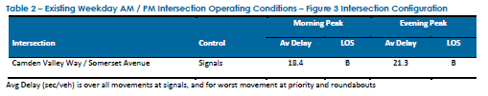

The following table outlines the conditions modelled as a result of the proposed development and forecast out to 2029 at the Somerset Avenue and Camden Valley Way intersection:

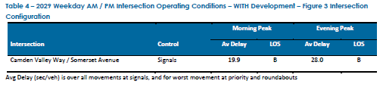

The traffic modelling shows that the level of service for the intersection will remain at category B and no further upgrades to the intersection are required.

Whilst it is acknowledged that the wait times at intersections are occasionally longer than normally recommended this is generally during school pick-up times. The proposal is not likely to result in unacceptable traffic wait times when averaged out across the entire hour or day.

The proposal was referred to the NSW Road and Maritime Services (RMS) for comment who raised no objection to the proposal.

Community Protection Through Environmental Design (CPTED)

The DA was referred to the Camden Local Area Command of the NSW Police for review and comment. The NSW Police raised no concerns subject to appropriate conditions of consent. In particular a recommended condition of consent requires front fencing to Somerset Avenue to be a minimum of 1.5m.

The applicant has acknowledged that long corridors to the communal entrances to the building could create hiding places. In response, the design has been amended to include openings and improve visibility as demonstrated in the below image:

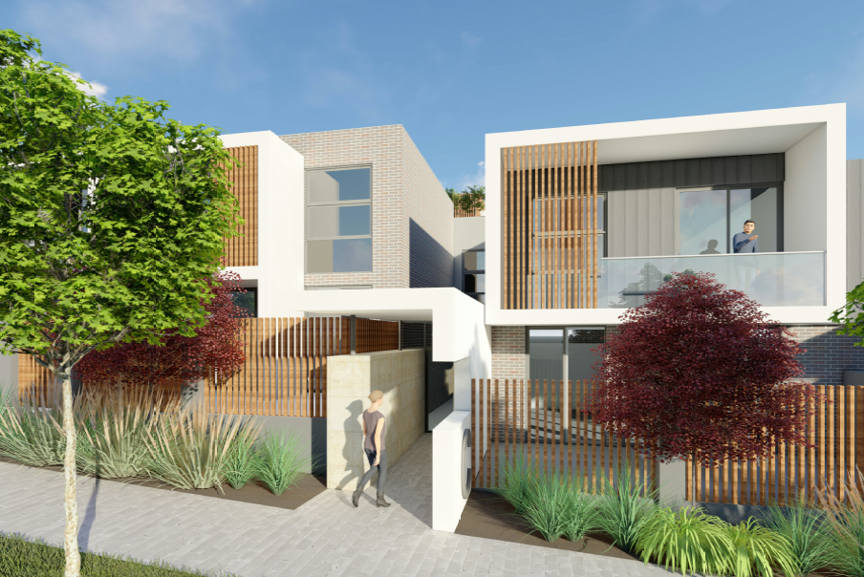
Figure 7: Artist impression of amended building entrances

Bulk and Scale

The immediate locality is generally made up of single dwelling houses, however the site is also adjacent to the Narellan Town Centre.

The design of the building has specifically responded to the split in building heights across the site in order to fully comply with the maximum height of buildings standard. Accordingly, the proposal includes two storey terrace style dwellings fronting Somerset Avenue stepping up to a maximum of four storeys at the rear.

The height, bulk, scale and form of the development is an appropriate response to the streetscape and the planning controls which guide the desired future character for the site.

(c) the suitability of the site for the development

As demonstrated by the above assessment, the site is considered to be suitable for the development.

(d) any submissions made in accordance with this Act or the regulations

The DA was notified to surrounding properties for a 14 day period between 13 May and 1 June 2019. Two submissions and two petitions signed by a total 106 people were received.

Both submissions and petitions raised concerns about traffic & parking congestion and the availability of public open space.

Traffic and Parking congestion

The proposal complies with Council’s minimum car parking rate including spaces for bicycles, loading and car washing. The car parking rates are based on the number of bedrooms per dwelling.

Whilst it is acknowledged that the proposed development will inevitably lead to an increase in the number of vehicles using roads in and around the Narellan Town Centre, the proposal includes the construction of a private road to limit the number of cars on Somerset Avenue.

Access to the basement carpark and servicing (including waste collection and removalist vehicles) is provided from the proposed private road within the site. Providing direct access to Elyard Street from the basement via the private road will ease the traffic burden on Somerset Avenue and divert vehicles towards the town center and Camden Valley Way.

A traffic and parking analysis was provided with the development application and the SIDRA analysis found that the current wait times and predicted wait times do not warrant any further upgrades to the existing intersections. The analysis found that the extended wait times are limited to the peak periods during school drop off and pick up times.

It is noted that the SIDRA outputs from the modelling did indicate that the queue length is forecast to rise up to 262.2m (95% back of Queue – Distance (Worst Lane)). Whilst the queue length may contribute to the perception of unreasonable queuing times, the outputs of the modelling demonstrate that the wait times are acceptable and within the category B service.

The queuing is likely a result of the on-street parking on Somerset Avenue limiting the availability of one lane for queuing. Notwithstanding this, it is reiterated that the existing and predicted wait times are acceptable. Furthermore, there is also the opportunity for Council to investigate ‘no stopping’ signs or similar traffic control measures to alleviate queuing pressure if required in future.

The application was referred to Council’s Traffic Team and the RMS for comment who both raised no issue with the proposal subject to appropriate conditions of consent.

Public Open Space

The site is adjacent to public reserves and the ‘Narellan Urban Forest’ and is in close proximity to sporting fields. The subject site is in private ownership and has no obligation to provide space for public use. It is noted that the developer will be required to pay Section 7.11 contributions for public open space land acquisition and recreation and community facilities.

In accordance with the requirements of the ADG, the proposed development provides sufficient private open space for each dwelling and greater than the minimum requirements for indoor and outdoor communal spaces for the use of all residents.

(e) the public interest

The public interest is served through the detailed assessment of this DA under the Environmental Planning and Assessment Act 1979, the Environmental Planning and Assessment Regulation 2000, environmental planning instruments, development control plans and policies. Based on the above assessment, the development is consistent with the public interest.

EXTERNAL REFERRALS

The external referrals undertaken for this DA are summarised in the following table:

External Referral | Response
NSW Rural Fire Service. | No objection, the proposal is not integrated.
Camden Police Local Area Command | No objection and conditions recommended.

Conditions that require compliance with the external referral recommendations are recommended.

CONCLUSION

The DA has been assessed in accordance with Section 4.15(1) of the Environmental Planning and Assessment Act 1979 and all relevant instruments, plans and policies. The DA is recommended for approval subject to the conditions attached to this report.

RECOMMENDED
That the Panel approve DA/2019/324/1 the construction of a residential flat building development comprising 100 dwellings at 38 – 58 Somerset Avenue and 3 Elyard Street, Narellan subject to the conditions attached to this report.

